**AUTOMATIC ATTENDANCE SYSTEM**

BACHELOR OF TECHNOLOGY

IN

**ELECTRONICS AND COMMUNICATION ENGINEERING**

**Submitted by:**

**KODURU POOJA (18011A0420)**

**SAKA SRINIVASULU (19015A0422)**

**RESHMA (18011A0437)**

**SHARAFUDDIN (18011A0459)**

Under the esteemed guidance of

**Dr. Makkena Madhavi Latha**

Professor & Director of Academic and Planning

Former Director, Innovative Technologies, JNTUH, LMISTE, FIETE, MIEEE

Electronics & Communication Engineering



**Department of Electronics and Communication Engineering**

**Jawaharlal Nehru Technological University Hyderabad**

**College of Engineering Hyderabad**

Autonomous

(Kukatpally-Hyderabad-500085)

2022

**Department Of Electronics and Communication Engineering**

**Jawaharlal Nehru Technological University Hyderabad**

Kukatpally, Hyderabad – 500085



CERTIFICATE BY THE SUPERVISOR

This is to certify that the project entitled “**AUTOMATIC ATTENDANCE SYSTEM**” is being submitted by

**KODURU POOJA (18011A0420)**

**SAKA SRINIVASULU (19015A0422)**

**RESHMA (18011A0437)**

**SHARAFUDDIN (18011A0459)**

in partial fulfilment of the requirements for the award of degree in Bachelors of Technology in Electronics and Communication Engineering at the Jawaharlal Nehru Technological University during the academic year 2021-22 is a bona fide work carried out under my guidance and supervision. The results embodied in this project report have not been submitted to any other University or institute for the award of any degree or diploma.

Supervisor:

**Dr. Makkena Madhavi Latha**

B. E., M. TECH., Ph. D

Professor & Director of Academic and Planning

Former Director, Innovative Technologies,

JNTUH, LMISTE, FIETE, MIEEE

Electronics &Communication Engineering

JNTUH Kukatpally

**Jawaharlal Nehru Technological University Hyderabad** Kukatpally, Hyderabad – 500085



**CERTIFICATE BY THE HEAD OF THE DEPARTMENT**

This is to certify that the project report entitled “**AUTOMATIC ATTENDANCE SYSTEM”** isSubmitted by

**KODURU POOJA (18011A0420)**

**SAKA SRINIVASULU (19015A0422)**

**RESHMA (18011A0437)**

**SHARAFUDDIN (18011A0459)**

In partial fulfilment of the requirements for the award of degree in Bachelor of Technology in Electronics and Communication Engineering at the Jawaharlal Nehru Technological University during the academic year 2021-22 is a Bona fide work carried out by them.

HEAD OF THE DEPARTMENT

**Dr. K ANITHA SHEELA**

Professor and Head,

Department Of ECE,

JNTUH CEH.

# Department Of Electronics and Communication Engineering Jawaharlal Nehru Technological University Hyderabad Kukatpally, Hyderabad – 500085



**DECLARATION OF THE CANDIDATES**

We hereby declare that the project report title “**AUTOMATIC ATTENDANCE SYSTEM**” is a bona fide record work done and submitted under the esteemed guidance of **Dr. MAKKENA MADHAVI LATHA**, Professor & Director of Academic and Planning, Former Director, Innovative Technologies, JNTUH, LMISTE, FIETE, MIEEE, Department of ECE, JNTUH CEH , in partial fulfilment of the requirements for Mini project in Electronics and Communication Engineering at the Jawaharlal Nehru Technological University during the academic year 2021-22 is a bona fide work carried out by us and the results kept in the minor project have not been reproduced. The results have not been submitted in any other institute of university for the award of degree or diploma.

**KODURU POOJA (18011A0420)**

**SAKA SRINIVASULU (19015A0422)**

**RESHMA (18011A0437)**

**SHARAFUDDIN (18011A0459)**

# ACKNOWLEDGEMENT

We take this opportunity to record our gratitude to all those who helped us in the successful completion of this project.

There are many people who helped us directly or indirectly to complete our project successfully. Firstly, we would like to express our deep gratitude towards our guide **Dr. Makkena Madhavi Latha** Professor & Director of Academic and Planning, Former Director, Innovative Technologies, JNTUH, LMISTE, FIETE, MIEEE, Department of ECE, Department of Electronics and Communication Engineering for her support in the completion of our dissertation.

We would like to express our sincere thanks to **Dr. K Anitha Sheela, HOD, Department of ECE** for providing the facilities to complete the dissertation. We would like to thank all our faculty and friends for their help and constructive criticism during the project period.

Finally, we are very much indebted to our parents for their moral support and encouragement to achieve goals.

**ABSTRACT**

Attendance marking in a classroom during a lecture is very time consuming. Attendance marking with conventional methods has been an area of challenge. The growing need of efficient and automatic techniques of marking attendance is a growing challenge in the area of face recognition.

In this proposed project an automated attendance marking and management system is proposed by making use of face detection and recognition algorithms. Instead of using the conventional methods, this proposed system aims to develop an automated system that records the student’s attendance by using facial recognition technology. The main objective of this work is to make the attendance marking and management system efficient, time saving, simple and easy.

Here faces will be recognized using face recognition algorithms. The processed image will then be compared against the existing stored record and then attendance is marked in the database accordingly. Compared to existing system traditional attendance marking system, this system reduces the workload of people. This proposed system will be implemented with 4 phases - Image Capturing and Face Detection, Feature Extraction, Face comparison and Recognition, Updating the Attendance.

**Image Capturing**

**And**

**Face Detection**

**Face Comparison And**

**Recognition**

**Feature Extraction**

**Updating the Attendance**

**;**

**Figure 1.1 : Block Diagram**

**CONTENTS**

ACKNOWLEDGEMENTS…………………………………………….5

ABSTRACT………………………………………………………...….6

LIST OF FIGURES…………………………………………………(9-10)

CHAPTER 1: INTRODUCTION (11-12)

1.1 Overview 11

1.2 Motivation 11

1.3 Goal 12

12

1.4 Methodology

CHAPTER 2: BACKGROUND (13-16)

2.1 Previous attendance systems 13

2.2 Importance of Face Recognition System 15

CHAPTER 3: PROJECT DESIGN (17-30)

3.1 Flowchart 17

3.2 Histogram of Gradients (18-20)

3.3 Deep Convolutional Neural Network (21-26)

3.3.1 RESNET 34 (23-26)

3.4 Face Distance (27-30)

CHAPTER 4: IMPLEMENTATION (31-34)

CHAPTER 5: RESULTS (35-53)

5.1 Loading Images to Database 35

5.2 Face Detection 36

5.3 Feature extraction (37-42)

5.3.1 Resnet output (38-42)

5.4 Face Recognition (43-44)

5.5 Update Attendance (45-46)

5.6 New Registration (46-47)

5.7 Speech Output 47

5.8 Face Recognition in different Scenarios (48-51)

5.8.1 Transformation 48

5.8.2 Beard 48

5.8.3 Age 49

5.8.4 Combining Faces (49-51)

5.9 Blurring The Image (52-53)

CHAPTER 6: ADVANTAGES AND DISADVANTAGES 54

CHAPTER 7: FUTURE SCOPE 55

CHAPTER 8: CONCLUSION 55

CHAPTER 9: REFERENCES 56

**LIST OF FIGURES**

|  |  |  |
| --- | --- | --- |
| FIGURE NO. | FIGURE NAME | PAGE NO. |
| 3.21 | Pixels surrounding the main pixel | 18 |
| 3.22 | Gradient of a Pixel | 18 |
| 3.23 | HOG Representation of an image | 19 |
| 3.24 | Matching our image with HOG Pattern | 20 |
| 3.25 | Detecting a Face | 20 |
| 3.31 | Tweaking the Neural Network | 21 |
| 3.32 | 128 Measurements Generated From an image | 22 |
| 3.34 | Convolutional Layers of Resnet 34 | 24 |
| 3.35 | Convolutional kernels for RESNET 34 | 26 |
| 3.41 | Cosine Similarity | 27 |
| 3.42 | Hamming Distance | 28 |
| 3.43 | Manhattan Distance | 29 |
| 3.44 | Euclidean Distance | 30 |
| 5.11 – 5.16 | Images in Database | 35 |
| 5.21 | Image Capturing | 36 |
| 5.22 | Face Detection | 36 |
| 5.31 | Input Image for Resnet | 38 |
| 5.32 | Convolution Layer-1 Filters | 40 |
| 5.33 | Convolution Layer-1 Output | 40 |
| 5.34 | Convolution Layer-2 Output | 41 |
| 5.35 | Convolution Layer-3 Output | 41 |
| 5.36 | Convolution Layer-4 Output | 42 |
| 5.41 | Face Recognition | 43 |
| 5.42 | Unknown Face Detection | 44 |
| 5.51 | Attendance Update | 45 |
| 5.61 | Input For New Registration | 46 |
| 5.82 | Makeover | 48 |
| 5.84 | Facial Hair | 48 |
| 5.86 | Age | 49 |
| 5.87 | 50 % of each image | 50 |
| 5.88 | 60 % one image and 40 % another | 50 |
| 5.89 | 35 % one image and 65 % another | 51 |
| 5.92 | No Blur | 52 |
| 5.94 | 30% Blurring | 52 |
| 5.96 | 60% Blurring | 53 |

**CHAPTER 1**

**INTRODUCTION**

**1.1 OVERVIEW**

Face recognition systems have upgraded appreciably in their management over the recent years and this technology is now vastly used for various objectives like security and in commercial operations. Face recognition is a powerful field of research which is a computer based digital technology. Face recognition for the intent of marking attendance is a resourceful application of attendance system. It is widely used in security systems and it can be compared with other biometrics such as fingerprint or eye iris recognition systems. Face recognition being a biometric technique implies determination if the image of the face of any particular person matches any of the face images that are stored in a database

**1.2 MOTIVATION**

Attendance maintenance is a significant function in all the institutions to monitor the performance of the students. Every institute does this in its own way. Some of these institutes use the old paper or file-based systems and some have adopted strategies of automatic attendance using some biometric techniques. A facial recognition system is a computerized biometric software which is suited for determining or validating a person by performing comparison on patterns based on their facial appearances. As the number of students in an educational institute or employees at an organization increases, the needs for lecturers or to the organization also increase the complication of attendance control.

Therefore, there exists a need for a system which is more easier, Quick and efficient. Hence, we propose this Automatic Attendance System based on face recognition to solve to cope with this problem

**1.3 GOAL**

The main objective of this work is to make the attendance marking and management system efficient, time saving, simple and easy.

**1.4 METHODOLOGY**

This proposed system aims to develop an automated system that records the student’s attendance by using facial recognition technology. Here faces will be recognized using face recognition algorithms. The processed image will then be compared against the existing stored record and then attendance is marked in the database accordingly.

It will be implemented by first Capturing the Image and then Detecting the face using HOG method. Later, using RESNET deep neural network face features are extracted. Then by using Euclidean Face Distance, person is identified and Attendance is updated.

A web cam is used for capturing the images of students or employees. The faces in the captured images are detected and compared with the images in database and the attendance is marked.

**CHAPTER 2**

**BACKGROUND**

**2.1 Drawbacks of previous attendance systems**

**DRAWBACKS OF MANUAL ATTENDANCE SYSTEM**

**Data manipulation**

As the data is recorded manually, it can be easily manipulated. The employees may put wrong information to garner extra wages. Moreover, this can create a “Time Theft” condition as well. As such, you will keep paying your staff for the time that they didn’t even work for.

**Possible human errors**

The attendance of staff needs to be compiled, keeping in mind the necessary compliance, remuneration, etc. However, when such tasks are done manually, the chances of human error get elevated.

**Speed**

Recording attendance manually is very time-consuming. This can affect productivity as well as the performance of the employees. Besides, it will also take your time to obtain the attendance data of all your employees manually. Furthermore, the entire process may even end up consuming a lot of your time in maintaining scorecards, rectifying errors related to time entry, among others. However, in case of an automated attendance system, you will be able to do all such tasks with just one click.

**Ineffective and outdated**

The manual methods of obtaining attendance are ineffective and getting out-of-fashion with the introduction of new technologies. As such, using such outdated methods can significantly affect business activities.

**DRAWBACKS OF BIOMETRIC ATTENDANCE SYSTEM**

**Traits Non changeable Physical:**

We can reset a password, but we never can change our fingerprints or retina, these are fixed. Our biometric data is stored in respective government’s databases or companies who enable such services. Can they guarantee that these data will never be hacked or stolen from the server? Unfortunately, it is already happening around us. There is news about data breach of billions of Indians’ private data from the Aadhaar database. A large-scale breach took place at the Federal Government Office of Personal Management in US where 5.6 million workers’ fingerprints were stolen in 2015. You can change your password if it is stolen, but you have no option to change your fingerprint in anyway.

**Rate of Error**Biometric attendance machines have two types of errors, False Acceptance Rate (FAR) and False Rejection Rate (FRR). FAR is happens when the device accepts an unauthorized person, and FRR comes into the picture when authorized person is rejected. The error rate is 1% that means an organization with 20,000 employee, will get an error attendance of approximately 200 employees.

**Delay**  
Biometric attendances devices take more time to mark the attendance and causes a long queue of workers in the morning and in the evening.

**Infection Carrier**  
Coronavirus spreads from human touch. If an employee touches the biometric attendance system with coronavirus and touch her surface, she is susceptible to getting infected from coronavirus. Everyone shares germs on biometric attendance management system.

**Difficulty in Scanning**  
Iris, finger prints are tough to scan. Eyelashes, eyelids, lens and reflections from the cornea can be difficult to scan and if finger is injured again a finger print scanner won't be able to scan the fingers.

**Physical Challenges**

Many employees have physical challenges due to lost or damaged physical parts. Thus, it is challenging to get them involved in the enrolment process.

**Environmental Challenges**  
Under extreme cold or extreme heat, the error rate is also very hight. Thus, this creates a challenge for using biometric attendance system.

**2.2 Need of Face Recognition System**

**WHAT IS FACE RECOGNITION?**

At its most basic, facial recognition involves identifying or verifying someone using characteristics and features of their face. Various technologies exist, including 3-D, Vascular and Heat Patterning and skin texture analysis. In the most prevalent type of facial recognition, algorithms identify certain points on the face, such as the shape of one’s chin, and create a template for that person. It is most accurate when users voluntarily submit their images into a limited database, such as a company network, for a use such as face access control. When the person approaches a facial scanner, their live image is captured and converted into a template, which is then compared to the templates stored in the database. A match enables the user to undertake some activity, such as passing through a door or logging into a computer network.

**WHY FACE RECOGNITION SYSTEM?**

### **Safety and Security**

Facial recognition technology has been used countless times to identify, interdict, and capture criminal suspects. In 2019, New York police used facial recognition to track down alleged rapist in 24 hours. It’s used as well for identity documents, at border checks, to identify missing children, to find human trafficking victims, and more. Perhaps its fastest growing application is as part of a facial recognition door access system.

### **Convenience**

When used in physical or lower access control systems facial recognition provides a passive, seamless, and frictionless access solution. Users don’t have to worry about forgetting their badge or the keypad combination. They need only pause momentarily at a camera, not stop and insert a hand or finger into a device. It is a completely touchless system when the door is configured to open automatically.

### **Customer Service**

Retailers, theatres, stadiums, and other facilities use facial recognition tailor the visitor or customer experience and cater to VIPs, such as providing concierge service. It can be used to create smart digital signage and to simplify the checkout process, as is the case in Amazon GO stores.

**Healthcare Advances**

Researchers at the National Human Genome Research Institute have used facial recognition software to make accurate diagnosis of DiGeorge Syndrome, a chromosomal disorder that causes many health challenges. Researchers compared 156 Latin Americans, Africans, Caucasians, and Asians with DiGeorge Syndrome against others without the ailment. Facial recognition yielded an almost 97%rate of correct diagnosis. Other healthcare applications include an app that makes sure patients take their medication as prescribed. And organizations are using it in the battle against Coronavirus. For example, CLEAR, the company that helps expedite travellers through security in U.S. airports, is rolling out a tool that uses facial recognition to determine whether an employee has Covid and should stay home.

**CHAPTER 3**

**PROJECT DESIGN**

**3.1 Flow Chart :**

Image Capturing And

Face Detection Using

HOG Method

Feature Extraction

Using Resnet Model

Face Comparison And

Recognition Using

Euclidean Distance

Updating the Attendance

In Excel Sheet

**Figure 3.11 : Flow diagram**

**3.2 Histogram of Gradients (HOG)**

We’re going to use a method invented in 2005 called Histogram of Oriented Gradients — or just **HOG** for short. To find faces in an image, we’ll start by making our image black and white because we don’t need colour data to find faces: Then we’ll look at every single pixel in our image one at a time. For every single pixel, we want to look at the pixels that directly surrounding it:

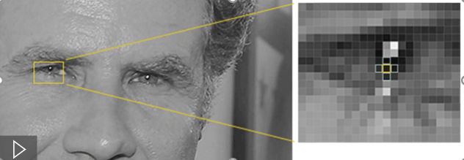

**Figure 3.21 : Pixels surrounding the main pixel**

( Reference : [https://miro.medium.com/max/875/1*RZS05e_5XXQdofdRx1GvPA.gif](https://miro.medium.com/max/875/1*RZS05e_5XXQdofdRx1GvPA.gif) )

Looking at just this one pixel and the pixels touching it as in figure 3.21 the image is getting darker towards the upper right. If you repeat that process for **every single pixel** in the image, you end up with every pixel being replaced by an arrow as shown in figure 3.22. These arrows are called *gradients* and they show the flow from light to dark across the entire image:

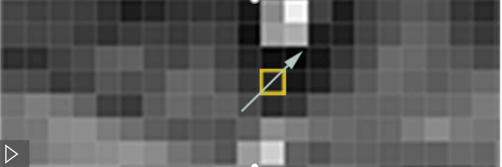

**Figure 3.22 : Gradient of a Pixel**

( Reference : [https://miro.medium.com/max/625/1*WF54tQnH1Hgpoqk-Vtf9Lg.gif](https://miro.medium.com/max/625/1*WF54tQnH1Hgpoqk-Vtf9Lg.gif) )

This might seem like a random thing to do, but there’s a really good reason for replacing the pixels with gradients. If we analyze pixels directly, really dark images and really light images of the same person will have totally different pixel values. But by only considering the *direction* that brightness changes, both really dark images and really bright images will end up with the same exact representation. That makes the problem a lot easier to solve!

To do this, we’ll break up the image into small squares of 16x16 pixels each. In each square, we’ll count up how many gradients point in each major direction (how many are point up, point up-right, point right, etc…). Then we’ll replace that square in the image with the arrow directions that were the strongest.

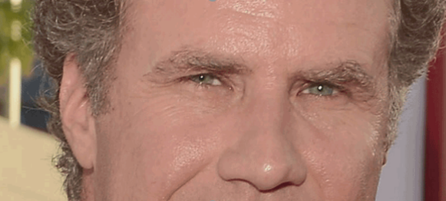

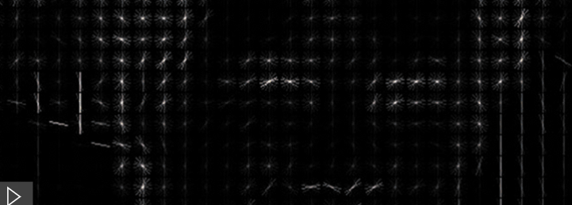

**Figure 3.23 : HOG Representation of an image**

( Reference : [https://miro.medium.com/max/875/1*uHisafuUw0FOsoZA992Jdg.gif](https://miro.medium.com/max/875/1*uHisafuUw0FOsoZA992Jdg.gif) )

The original image is turned into a HOG representation that captures the major features of the image regardless of image brightness as in figure 3.23. To find faces in this HOG image, all we have to do is find the part of our image that looks the most similar to a known HOG pattern that was extracted from a bunch of other training faces as shown in left half of figure 3.24.

Using this technique, we can now easily find faces in any image:

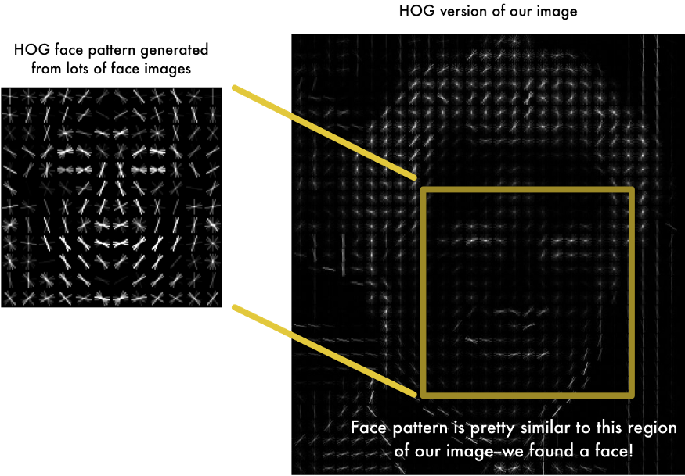

**Figure 3.24 : Matching our image with HOG Pattern**

( Reference : [https://miro.medium.com/max/875/1*6xgev0r-qn4oR88FrW6fiA.png](https://miro.medium.com/max/875/1*6xgev0r-qn4oR88FrW6fiA.png) )

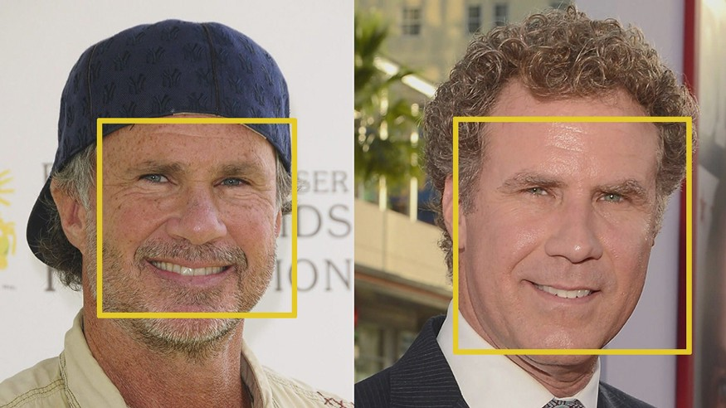

**Figure 3.25 : Detecting a Face**

( Reference : [https://miro.medium.com/max/875/1*dOtP6yl7d4c0oaR6NpfWVg.jpeg](https://miro.medium.com/max/875/1*dOtP6yl7d4c0oaR6NpfWVg.jpeg) )

As shown in figure 3.25, we can see that by comparing with the known HOG pattern we can successfully detect the face location in an image.

**3.3 Deep Convolutional Neural Network**

It turns out that the measurements that seem obvious to us humans (like eye colour) don’t really make sense to a computer looking at individual pixels in an image. Researchers have discovered that the most accurate approach is to let the computer figure out the measurements to collect itself. Deep learning does a better job than humans at figuring out which parts of a face are important to measure. The solution is to use a Deep Convolutional Neural Network

The training process works by looking at 3 face images at a time:

1. Load a training face image of a known person
2. Load another picture of the same known person
3. Load a picture of a totally different person

As in figure 3.31 the algorithm looks at the measurements it is currently generating for each of those three images. It then tweaks the neural network slightly so that it makes sure the measurements it generates for #1 and #2 are slightly closer while making sure the measurements for #2 and #3 are slightly further apart:

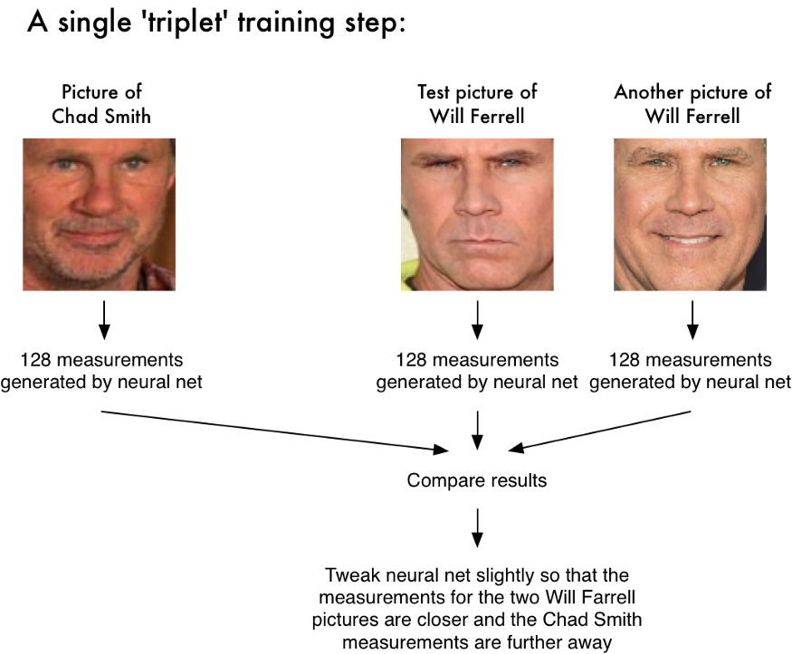

**Figure 3.31 : Tweaking the Neural Network**

( Reference : [https://miro.medium.com/max/875/1*n1R8VMyDRw3RNO3JULYBpQ.png](https://miro.medium.com/max/875/1*n1R8VMyDRw3RNO3JULYBpQ.png) )

After repeating this step for millions of images of different people, neural network learns to reliably generate roughly the same 128 measurements (see figure 3.32 ) for different pictures of the same person. Machine learning people call the 128 measurements of each face an **embedding**.

This process of training a convolutional neural network to output face embeddings requires a lot of data and computer power. Even with an expensive [NVidia Telsa video card](http://www.nvidia.com/object/tesla-supercomputing-solutions.html), it takes [about 24 hours](https://twitter.com/brandondamos/status/757959518433243136) of continuous training to get good accuracy. But once the network has been trained, it can generate measurements for any face, even ones it has never seen before! So this step only needs to be done once. Lucky for us, the fine folks at [OpenFace](https://cmusatyalab.github.io/openface/) already did this and they [published several trained networks](https://github.com/cmusatyalab/openface/tree/master/models/openface) which we can directly use. Thanks [Brandon Amos](http://bamos.github.io/) and team!

So all we need to do ourselves is run our face images through their pre-trained network to get the 128 measurements for each face. The network generates nearly the same numbers when looking at two different pictures of the same person :

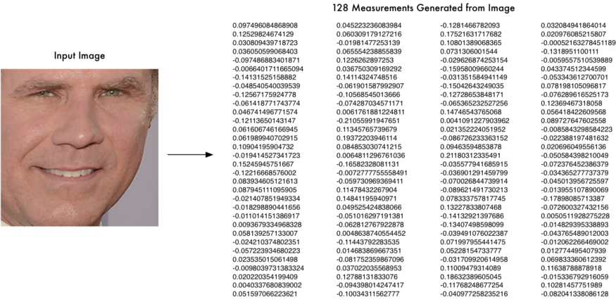

**Figure 3.32 : 128 Measurements Generated From an image**

( Reference : [https://miro.medium.com/max/875/1*6kMMqLt4UBCrN7HtqNHMKw.png](https://miro.medium.com/max/875/1*6kMMqLt4UBCrN7HtqNHMKw.png) )

**3.3.1 RESNET 34**

Resnet34 is a 34 layer convolutional neural network ( see figure 3.34 )that can be utilized as a state-of-the-art image classification model. This is a model that has been pre-trained on the ImageNet dataset--a dataset that has 100,000+ images across 200 different classes.

* According to the universal approximation theorem, given enough capacity, we know that a feedforward network with a single layer is sufficient to represent any function. However, the layer might be massive and the network is prone to overfitting the data. Therefore, there is a common trend in the research community that our network architecture needs to go deeper.
* stacking layers shouldn’t degrade the network performance, because we could simply stack identity mappings (layer that doesn’t do anything) upon the current network, and the resulting architecture would perform the same. This indicates that the deeper model should not produce a training error higher than its shallower counterparts. They hypothesize that letting the stacked layers fit a residual mapping is easier than letting them directly fit the desired underlaying mapping. And the residual block above explicitly allows it to do precisely that.
* As shown in figure 3.33 The core idea of Resnet is introducing a so-called “identity shortcut connection” that skips one or more layers, as shown in the following figure:

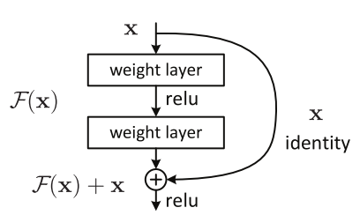

**Figure 3.33 : Residual block in resnet**

( Reference : [https://miro.medium.com/max/510/1*ByrVJspW-TefwlH7OLxNkg.png](https://miro.medium.com/max/510/1*ByrVJspW-TefwlH7OLxNkg.png) )

What is residual image?

Residual image is defined as **the difference between images before and after the manipulation**. The advantage of using the residual image is, the manipulation can be operated efficiently with a modest amount of pixel modification.

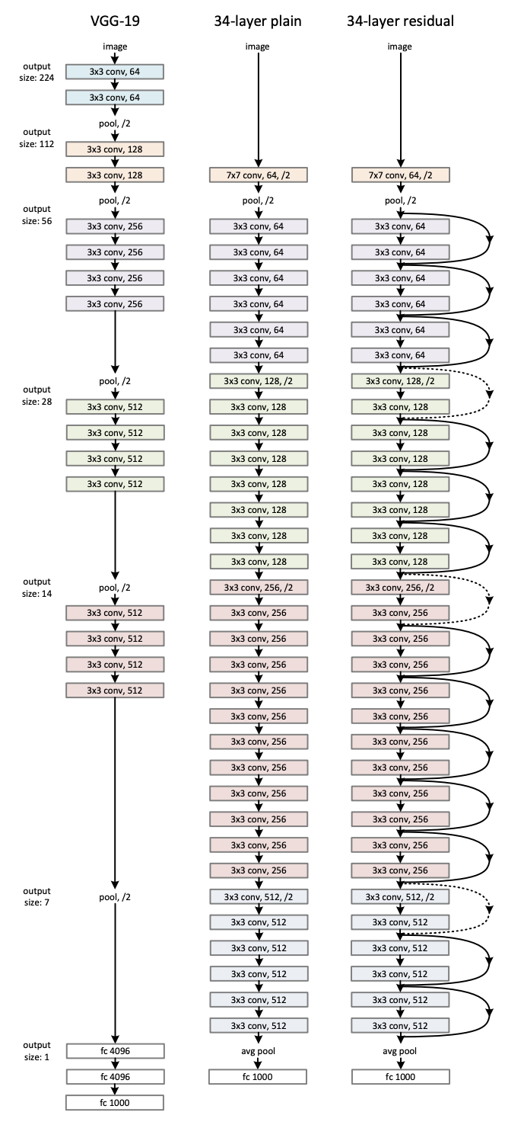

**Figure 3.34 : Layers of Resnet-34**

( Reference: [https://miro.medium.com/max/1000/1*2ns4ota94je5gSVjrpFq3A.png](https://miro.medium.com/max/1000/1*2ns4ota94je5gSVjrpFq3A.png) )

Pooling Layers

Convolutional layers in a convolutional neural network systematically apply learned filters to input images in order to create feature maps that summarize the presence of those features in the input. Convolutional layers prove very effective, and stacking convolutional layers in deep models allows layers close to the input to learn low-level features (e.g. lines) and layers deeper in the model to learn high-order or more abstract features, like shapes or specific objects.

A limitation of the feature map output of convolutional layers is that they record the precise position of features in the input. This means that small movements in the position of the feature in the input image will result in a different feature map. This can happen with re-cropping, rotation, shifting, and other minor changes to the input image. A common approach to addressing this problem from signal processing is called down sampling. This is where a lower resolution version of an input signal is created that still contains the large or important structural elements, without the fine detail that may not be as useful to the task.

Down sampling can be achieved with convolutional layers by changing the [stride of the convolution across the image](https://machinelearningmastery.com/padding-and-stride-for-convolutional-neural-networks/). A more robust and common approach is to use a pooling layer. A pooling layer is a new layer added after the convolutional layer. Specifically, after a nonlinearity (e.g: RELU) has been applied to the feature maps output by a convolutional layer; for example the layers in a model may look as follows:

1. Convolutional Layer
2. Nonlinearity
3. Pooling Layer

Pooling involves selecting a pooling operation, much like a filter to be applied to feature maps. The size of the pooling operation or filter is smaller than the size of the feature map; specifically, it is almost always 2×2 pixels applied with a stride of 2 pixels. This means that the pooling layer will always reduce the size of each feature map by a factor of 2,

Eg: each dimension is halved, reducing the number of pixels or values in each feature map to one quarter the size. For example, a pooling layer applied to a feature map of 6×6 (36 pixels) will result in an output pooled feature map of 3×3 (9 pixels).

The pooling operation is specified, rather than learned. Two common functions used in the pooling operation are:

* **Average Pooling**: Calculate the average value for each patch on the feature map.
* **Maximum Pooling (or Max Pooling)**: Calculate the maximum value for each patch of the feature map.

The result of using a pooling layer and creating down sampled or pooled feature maps is a summarized version of the features detected in the input. They are useful as small changes in the location of the feature in the input detected by the convolutional layer will result in a pooled feature map with the feature in the same location. This capability added by pooling is called the model’s invariance to local translation.

* Convolution layers depending on the order are capable of selecting edges/objects…
* The layers close to input detect edges
* The deeper layers detect shapes/objects….

In the figure 3.35 , there is a summary of the output size at every layer and the dimension of the convolutional kernels at every point in the structure.

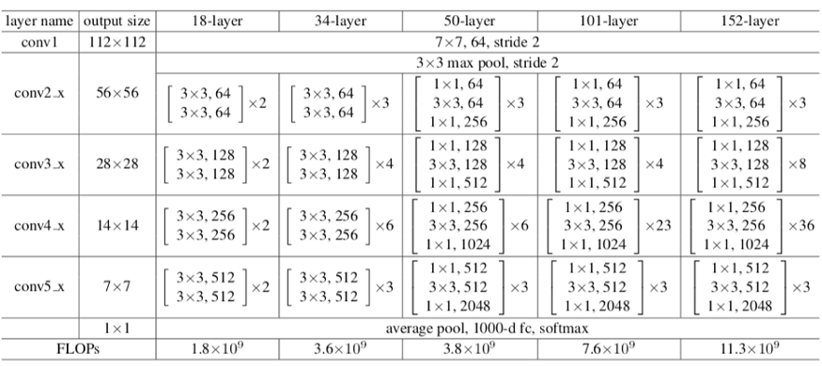

**Figure : 3.35 convolutional kernels for RESNET 34**

( Reference : [https://miro.medium.com/max/875/1*79h6LnY8Iirby1Bua7Ppbg.png](https://miro.medium.com/max/875/1*79h6LnY8Iirby1Bua7Ppbg.png) )

**3.4 Face Distance**

**Cosine Similarity**

Cosine similarity has often been used as a way to counteract Euclidean distance’s problem with high dimensionality. The cosine similarity is simply the cosine of the angle between two vectors x and y as in figure 3.41. It also has the same inner product of the vectors if they were normalized to both have length one. Two vectors with exactly the same orientation have a cosine similarity of 1, whereas two vectors diametrically opposed to each other have a similarity of -1.

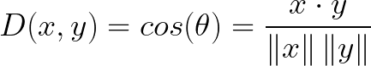

## 

x

y

**Figure 3.41 : Cosine Similarity**

( Reference : [https://miro.medium.com/max/1400/1*FTVRr_Wqz-3_k6Mk6G4kew.png](https://miro.medium.com/max/1400/1*FTVRr_Wqz-3_k6Mk6G4kew.png) )

## **Disadvantages**

One main disadvantage of cosine similarity is that the magnitude of vectors is not taken into account, merely their direction. In practice, this means that the differences in values are not fully taken into account. If you take a recommender system, for example, then the cosine similarity does not take into account the difference in rating scale between different users.

# Hamming Distance

Hamming distance is the number of values that are different between two vectors. It is typically used to compare two binary strings of equal length. It can also be used for strings to compare how similar they are to each other by calculating the number of characters that are different from each other. In figure 3.42, the no. of different bits is 2, resulting in a hamming distance of 2.

## 

## **Figure 3.42 : Hamming Distance**

( Reference : [https://miro.medium.com/max/1400/1*FTVRr_Wqz-3_k6Mk6G4kew.png](https://miro.medium.com/max/1400/1*FTVRr_Wqz-3_k6Mk6G4kew.png) )

## **Disadvantages**

* As you might expect, hamming distance is difficult to use when two vectors are not of equal length. You would want to compare same-length vectors with each other in order to understand which positions do not match.
* Moreover, it does not take the actual value into account as long as they are different or equal. Therefore, it is not advised to use this distance measure when the magnitude is an important measure.

# Manhattan Distance

# The Manhattan distance, often called Taxicab distance or City Block distance, calculates the distance between real-valued vectors. Imagine vectors that describe objects on a uniform grid such as a chessboard. Manhattan distance then refers to the distance between two vectors x and y if they could only move right angles as in figure 3.43 . There is no diagonal movement involved in calculating the distance.

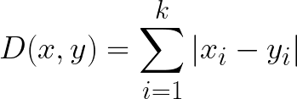

## 

x

y

## **Figure 3.43 : Manhattan Distance**

( Reference : [https://miro.medium.com/max/1400/1*FTVRr_Wqz-3_k6Mk6G4kew.png](https://miro.medium.com/max/1400/1*FTVRr_Wqz-3_k6Mk6G4kew.png) )

## **Disadvantages**

* Although Manhattan distance seems to work okay for [high-dimensional data](https://www.quora.com/What-is-the-difference-between-Manhattan-and-Euclidean-distance-measures), it is a measure that is somewhat less intuitive than Euclidean distance, especially when using in high-dimensional data.
* Moreover, it is more likely to give a higher distance value than Euclidian distance since it does not the shortest path possible. This does not necessarily give issues but is something you should take into account.

**Distance Measurement using Euclidian Distance**We start with the most common distance measure, namely Euclidean distance. It is a distance measure that best can be explained as the length of a segment. The formula is rather straightforward as the distance is calculated from the cartesian coordinates of the points (in figure 3.44 )using the Pythagorean theorem.

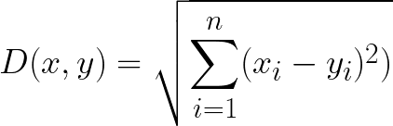

## 

## **Figure 3.44 : Euclidean Distance**

( Reference : [https://miro.medium.com/max/1400/1*FTVRr_Wqz-3_k6Mk6G4kew.png](https://miro.medium.com/max/1400/1*FTVRr_Wqz-3_k6Mk6G4kew.png) )

Calculation of Distances

Although many other measures have been developed to account for the disadvantages of Euclidean distance, it is still one of the most used distance measures for good reasons. It is incredibly intuitive to use, simple to implement and shows great results in many use-cases. The Euclidean distance can be used to calculate the distance between any two points in two-dimensional space, and also to measure the absolute distance between points in N-dimensional space. For face recognition, **smaller values indicate more similar faces**. The feature points representing facial features were calculated according to the Haar feature values, the image to be detected is processed by a function to obtain a 128-dimensional face feature vector, this constitutes the condition for face similarity calculation under Euclidean distance.

**Chapter 4**

**Implementation**

**STEP 1 : IMPORTING ALL THE REQUIRED LIBRARIES**

Here all the required python libraries like opencv , numpy , face_recognition are imported successfully

**OPENCV**

**OpenCV** provides a real-time optimized Computer Vision library, tools, and hardware. It also supports model execution for Machine Learning (ML) . OpenCV is an open-source BSD-licensed library that includes several hundreds of computer vision algorithms. OpenCV has a modular structure, which means that the package includes several shared or static libraries. The following modules are available:

* [Object Detection](https://docs.opencv.org/3.4.15/d5/d54/group__objdetect.html) (objdetect) - detection of objects and instances of the predefined classes (for example, faces, eyes, mugs, people, cars, and so on).
* [Image Processing](https://docs.opencv.org/3.4.15/d7/dbd/group__imgproc.html) (imgproc) - an image processing module that includes linear and non-linear image filtering, geometrical image transformations (resize, affine and perspective warping, generic table-based remapping), color space conversion, histograms, and so on.
* [Video Analysis](https://docs.opencv.org/3.4.15/d7/de9/group__video.html) (video)
* [Core functionality](https://docs.opencv.org/3.4.15/d0/de1/group__core.html) (core)
* [Camera Calibration and 3D Reconstruction](https://docs.opencv.org/3.4.15/d9/d0c/group__calib3d.html) (calib3d
* [2D Features Framework](https://docs.opencv.org/3.4.15/da/d9b/group__features2d.html) (features2d)
* [High-level GUI](https://docs.opencv.org/3.4.15/d7/dfc/group__highgui.html) (highgui)
* [Video I/O](https://docs.opencv.org/3.4.15/dd/de7/group__videoio.html) (videoio)

DLIB

Recognize and manipulate faces from Python or from the command line with

the world’s simplest face recognition library. Built using [dlib](http://dlib.net/)’s state-of-the-art face recognition built with deep learning. The model has an accuracy of 99.38%.

Dlib is a modern C++ toolkit containing machine learning algorithms and tools for creating complex software in C++ to solve real world problems. It is used in both industry and academia in a wide range of domains including robotics, embedded devices, mobile phones, and large high performance computing environments. Dlib’s open source licencing allows you to use it in any application, free of charge.

## Major Features -

* High Quality Portable Code
* Machine Learning Algorithms
* Numerical Algorithms
* Graphical Model Inference Algorithms
* Image Processing
* Threading
* Networking
* Graphical User Interfaces
* Data Compression and Integrity Algorithms

NUMPY

* Provides An array object of arbitrary homogeneous items
* Fast mathematical operations over arrays
* Main Functionalities are Linear Algebra, Fourier Transforms, Random Number Generation

**STEP 2 : LOADING IMAGES FROM DATABASE**

* In this step all the images are loaded from the database
* They are stored in a list to perform comparisons for the input image
* The names or ID’s of the images are stored in an other list to access while marking attendance

**STEP 3 : FEATURE EXTRACTION OF IMAGES FROM DATABASE**

* Each image from the database is first converted into RGB format using ‘cvtColor( )’ module of OpenCV library.
* Then the 128 computer generated encodings of each image is stored in a list , to avoid the calculation overhead each time.

**STEP 4 : CAPTURE THE IMAGE**

In this step the image is captured using ‘VideoCapture( )’ module and then it is read using the ‘read( )’ method of OpenCV library.

**STEP 5 : RESIZING THE IMAGE AND FACE DETECTION**

* In this step the captured image is reduced to 25% of its size to speed up the process using ‘resize( )’ method of OpenCV library.
* Then the location of images is found ‘face_locations( )’ module of face_recognition library.
* Face Detection is done by using **HOG** method .
* **HOG** method detects the face locations using the gradient map of an image as discussed in **section 4.2**

**STEP 6 : FEATURE EXTRACTION OF THE IMAGE**

* Here the features of each face in the image are extracted one at a time using ‘face_encodings( )’ module of face_recognition library.
* Feature extraction is done by using a deep convolutional neural network tweaked in such a manner that same encodings are produced for two different images of a same person only.
* The neural network we used here is the **RESNET** model as discussed in **section 4.3.1**

**STEP 7 : CALCULATING FACE DISTANCE AND FACE RECOGNITION**

* Now face distance is calculated for the captured image against each image in the database .
* Face distance is calculated using ‘face_distance( )’ module.
* This is done using **Euclidean Distance** as discussed in **section 4.4**
* Using this distance we recognise a face-
* If face_distance is closer to 0 then it is a match
* If face_distance is closer to 1 then it is not a match
* If face_distance is greater than 0.6 against all images in the database, then it means that the captured image has an unknown face and requires registration.
* Once the face is recognised, it is displayed with a face detection box along with their name. Also the name is spelled out using the speech engine of ‘pyttsx3’ module

**STEP 8 : MARKING THE ATTENDANCE FOR A KNOWN FACE**

Once there is a match attendance is marked for a particular lecture only by comparing with the current time. If the time is out of the lecture time, then face is recognised but attendance is not marked.

**STEP 9 : REGISTERING AN UNKNOWN FACE**

If an unknown face is detected, then the user is prompted to register. The registration is possible only if they know the password to ensure authenticity. Once the user is registered his attendance is marked from next time.

**STEP 10 : RESULTS STORED IN CSV FILE**

The Attendance marked is stored in a CSV file. It is even displayed in the output. For readability, we can open in excel sheet and view the results.

**CHAPTER 5**

**RESULTS AND ANALYSIS**

**5.1 Loading images from database**

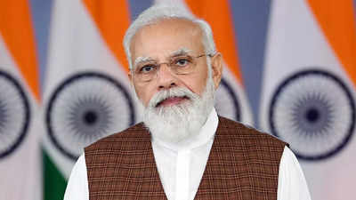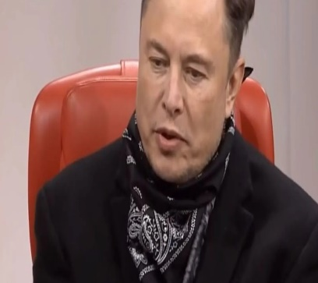 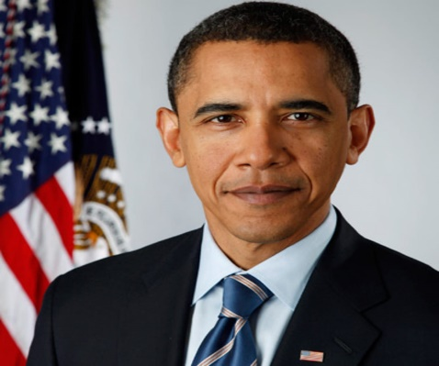  
 **Figure 5.11 : ELON MUSK Figure 5.12 : MODI Figure 5.13 : OBAMA**

(Image Size : 1600*900 ) (Image Size : 400*225 ) (Image Size : 1200*1200 )

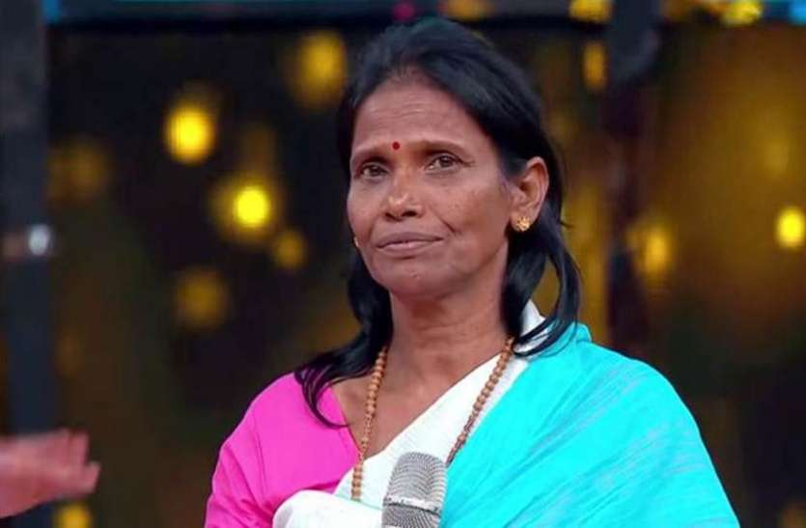 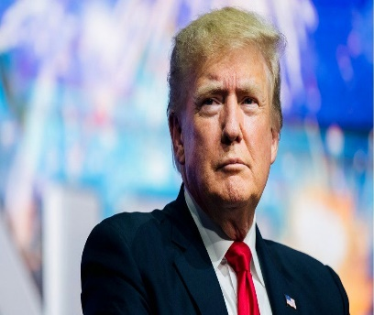 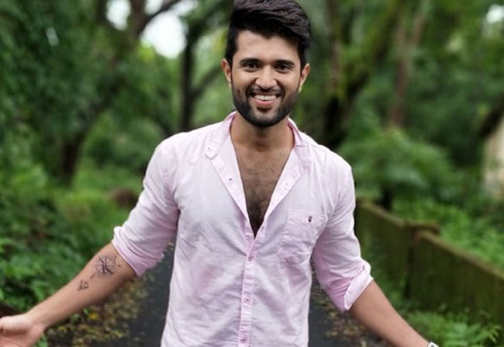 **Figure 5.14 : RANU MONDAL Figure 5.15: TRUMP Figure 5.16 :VIJAY DEVARAKONDA**

(Image Size : 835 * 547) (Image Size : 976*549 ) (Image Size : 650*447 )

Database Creation

* Database is created by collecting the images from various websites in google
* The Images can be of any size as indicated. It will not effect further analysis.
* They can be of any format like jpg, mpeg , png etc.

**5.2 Face Detection**

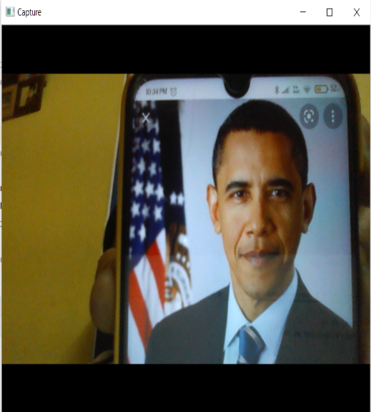

**Figure 5.21 : Image Capturing**

( Image Size : 640*480 )

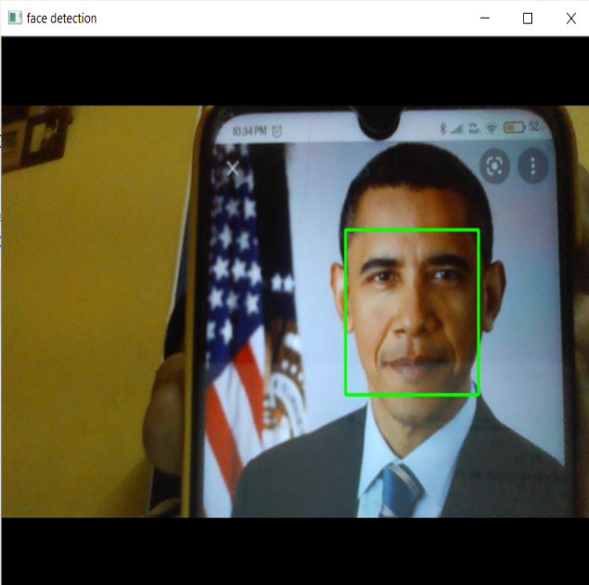

**Figure 5.22 : Face Detection**

(Image Size : 144*144 )

Analysis

* Face Detection is done using HoG Method
* Fig 5.21 shows the captured image.
* Fig 5.22 shows the face location enclosed in a square box
* Here we see that for any input size of image in figure 5.21, the size of the face detection boundaries will be fixed 144*144 only as in figure 5.22.

**5.3 Feature Extraction**

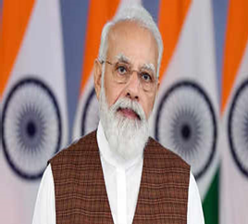

[array ([-0.10500369, 0.10367454, 0.10855722, -0.05611433, -0.03610793, 0.00966437, -0.110163, -0.07717933, 0.20730984, -0.1447197 ,0.2379209, 0.07051159, -0.2132621, -0.12762016, 0.02740259,0.12139519, -0.17789975, -0.063393, -0.11347357, -0.02750708,-0.03386248, 0.02205437, 0.08833348, 0.01035412, -0.06938653,-0.42752823, -0.06728487, -0.11136122, 0.00296318, -0.13684285,-0.12706004, -0.04199716, -0.19114196, -0.10937305, -0.03971103,0.01705343, -0.06468537, -0.00443462, 0.19697049, 0.05080397,-0.18102154, 0.05379225, 0.00632247, 0.22073063, 0.26998696, 0.0829182, 0.00454734, -0.11699037, 0.16505516, -0.22348297, 0.07776505, 0.17111267, 0.11426484, 0.03846893, 0.10978261,-0.15421742, -0.03556509, 0.08807757, -0.09785394, 0.02848792, 0.0450714, -0.0299075, -0.03084557, 0.02127388, 0.19009638, 0.09926832, -0.10558377, -0.06448189, 0.10246245, -0.07241705, 0.01426741, 0.01626392, -0.16002183, -0.22040947, -0.26210794, 0.07274698, 0.32148698, 0.14910495, -0.20690019, -0.03290031, -0.14162531, -0.01258349, 0.08215818, 0.08400106, -0.08363825, -0.04285945, -0.02775156, 0.05058604, 0.10962137, 0.00696662, 0.00194957, 0.19249433, 0.01616885, 0.06635091, 0.01900712, 0.03115548, -0.13962537, -0.0116617, -0.21169946, -0.02560067, 0.03787988, -0.01402417, 0.02430313, 0.08492788, -0.19411726, 0.1072536, 0.03966178, -0.0553496, 0.05699042, 0.02247842,-0.06960306, -0.08313447, 0.09515635, -0.194738, 0.23345108, 0.21313979, 0.02189298, 0.17491542, 0.09278131, 0.06061981, -0.02763408, 0.00891918, -0.10509896, -0.05083942, 0.05766249,0.05359597, 0.08700094, -0.02569399])]

( These are the 128 computer generated encodings of an input image. These encodings will be almost same for any two different images of the same person.)

**5.3.1 Resnet Output**

Input image

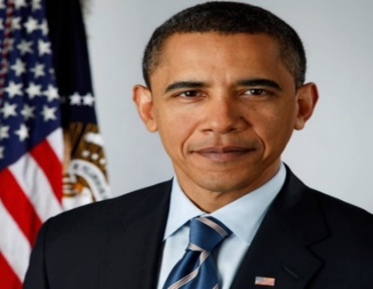

**Figure 5.31 : Input Image for Resnet**

OUTPUT

* Figure 5.32 shows the composition or the architecture of the resnet 34 deep neural network.
* It shows the various layer names along with their output shape
* The output shape contains coordinates of size of the image that would be after passing through that layer
* The third parameter in the output shape tells about the depth of the image
* For example, output shape = (224*224*3) conveys that the size of the image at present is 224*224. Also the network has traversed into the image by a depth of 3
* As the number of layers increase, the size of image decreases, increasing the processing speed
* Also the depth of the image increases with the number of layers

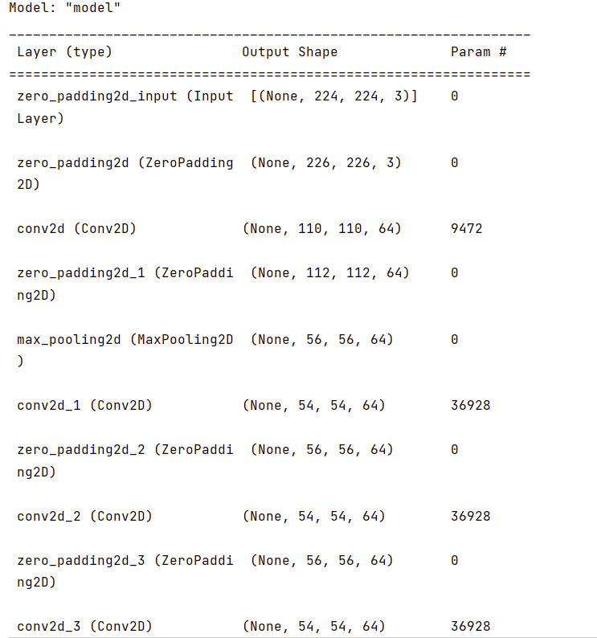

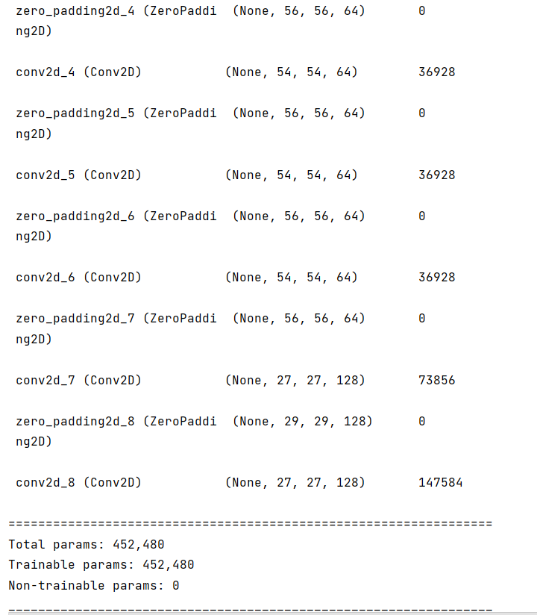

**Figure 5.2 : Building the Convolutional network**

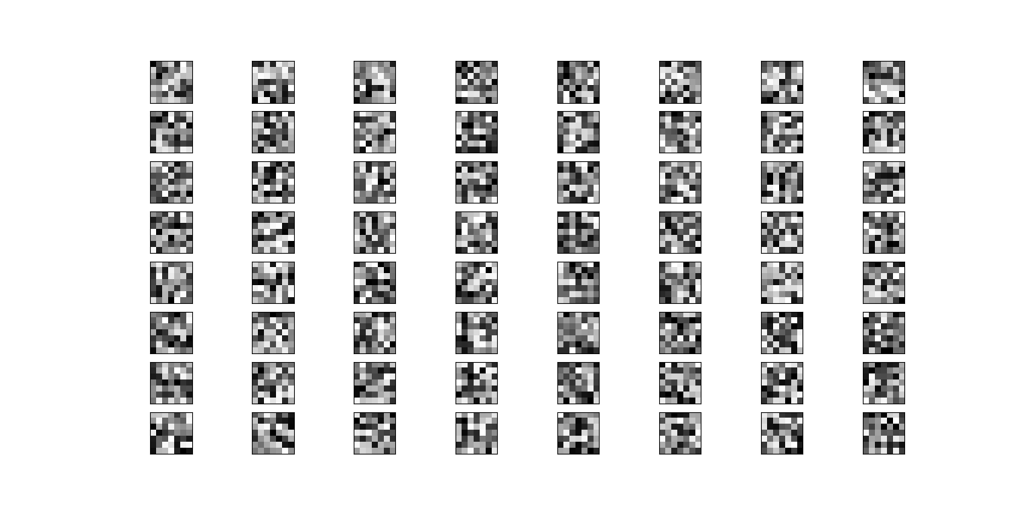

**Figure : 5.33 ConvolutionLayer-1 Filters**

( Figure 5.33 shows the 64 filters that exist in the first convolutional layer. Each convolutional layer tries to extract edges or objects in an image depending on the filters)

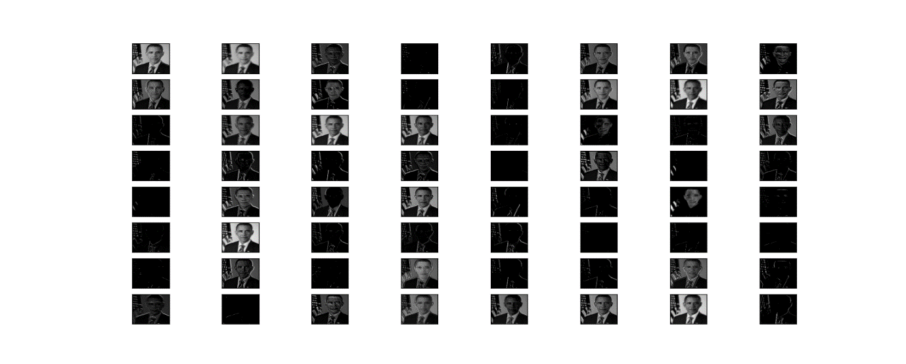

**Figure : 5.34 ConvolutionLayer-1 output (Attempt to preserve everything)**

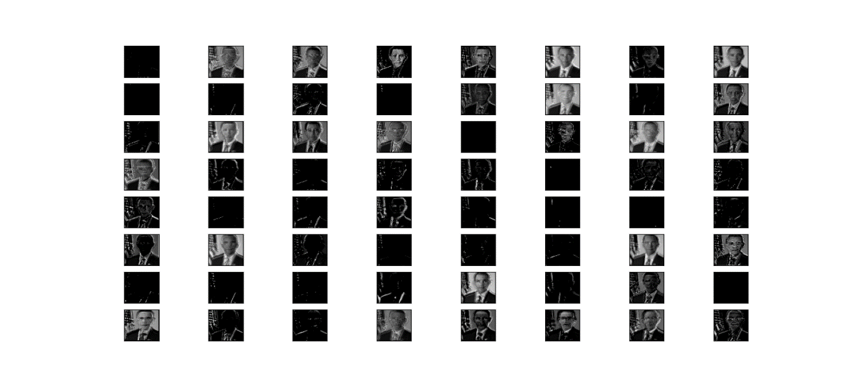

**Figure : 5.35 ConvolutionLayer-2 output (edge detection)**

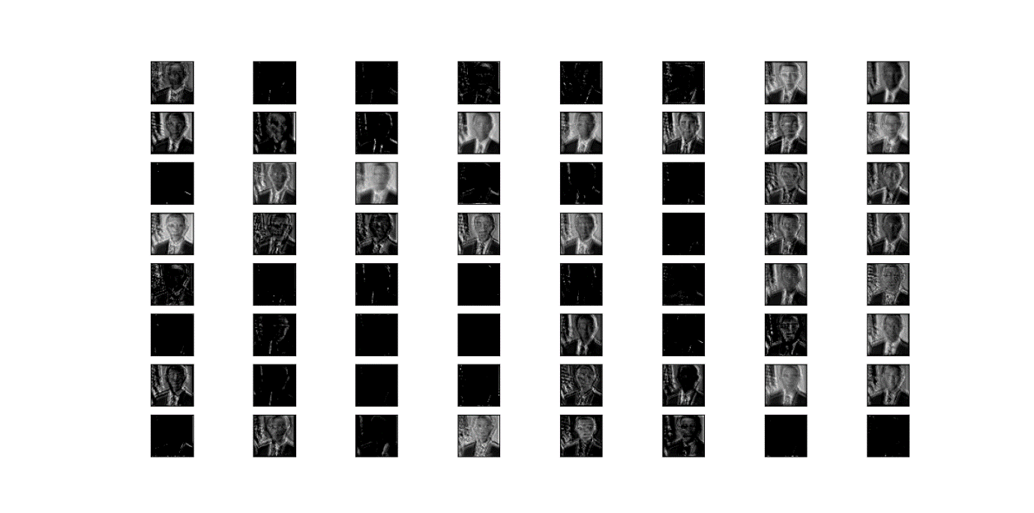 **Figure : 5.36 ConvolutionLayer-3 Output (Focus on face)**

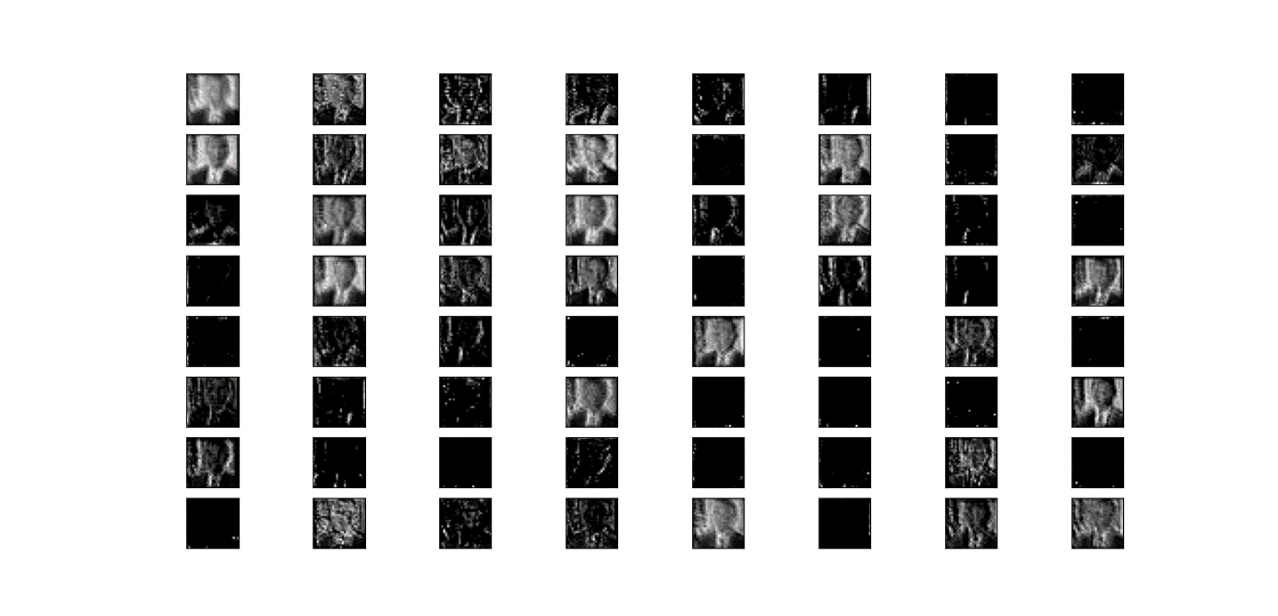

**Figure : 5.37 ConvolutionLayer-4 Output (Complex to understand)**

**Analysis**

* Here the first convolution layer (figure 5.34) attempts to preserve everything from an image.
* As we go deeper, the convolutional layers focus on the edges of the face (see figure 5.35).
* As we go even deeper, we see that the layers try to concentrate on particular features of the face like eyes, ears etc (see figure 5.36).
* Going more deeper it is beyond our understanding to the naked eye about what the layers try to preserve (see figure 5.37).
* We see that some of the filter outputs are blank in the layers. That is because there isn’t any such feature in the image, which that particular filter wants to preserve
* The sparsity of the activations is increasing with the depth of the layer: in the first layer, all filters are activated by the input image, but in the following layers more and more filters are blank. This means that the pattern encoded by the filter isn't found in the input image.
* The features extracted by a layer get increasingly abstract with the depth of the layer. The activations of layers higher-up carry less and less information about the specific input being seen, and more and more information about the target (in our case, recognise a face).

**5.4 Face recognition**

Case 1 : Image from Database

[elon , modi , Obama , pooja, ranu_mondal , trump , VijayDevarakonda]

[0.80168596 0.756043 0.91000097 0.97543046 0.92032433 0.58225766 0.88464374]

TRUMP

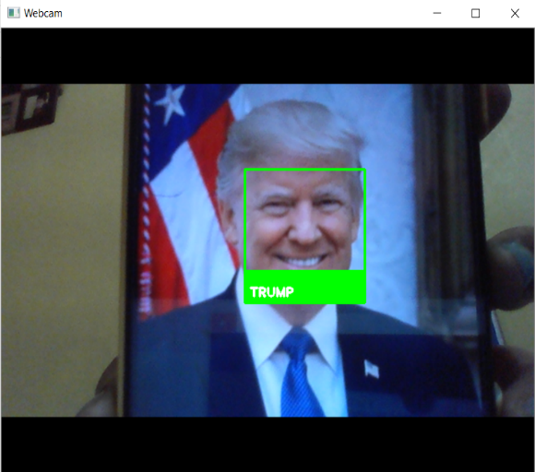

**Figure 5.41 : Face Recognition**

* Here we see in figure 5.41 that when the input matches with some image in database then it is recognised correctly, and the name is displayed below the face detection box
* Here we also see that the face distances are approaching to 1 indicating no match for all others except trump
* The face distance is least and closer to 0.5 for only trump. So the image is rightly recognised as trump

Case 2 : Unknown face as input

[elon , modi , Obama , pooja, ranu_mondal , trump , VijayDevarakonda]

[0.79037913 0.71326356 0.77914731 0.86170859 0.8271569 0.89759624 0.88475811]

WARNING: unknown face detected

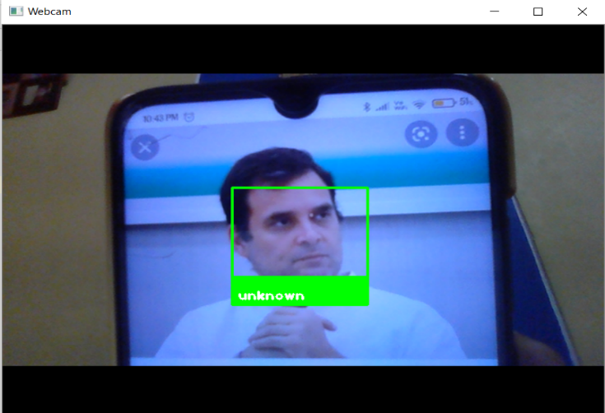

**Figure 5.42 : Unknown Face Detection**

* Here we see in figure 5.42 that when the input matches with no image in database then it is recognised correctly as unknown face and unknown is displayed below the face detection box
* Here we also see that the face distances are approaching to 1 for all images indicating no match .

**5.5 Updating the Attendance**

CSV Output:

Name, Date, Lecture1, Lecture2, Lecture3  
POOJA,01-05-2022,09:33:14,10:36:02,11:36:17  
ELON,01-05-2022,09:33:41,, 11:36:44  
MODI,01-05-2022,09:34:03,,  
OBAMA,01-05-2022,,10:34:38,11:36:31  
RANU_MONDAL,01-05-2022,,10:35:58,  
TRUMP,01-05-2022,,10:35:20,  
VIJAYDEVARAKONDA,01-05-2022,,10:35:45,  
VIJAYDEVARAKONDA,01-06-2022,09:37:07,,11:39:32  
POOJA,01-06-2022,09:37:36,10:38:14,11:39:00  
RANU_MONDAL,01-06-2022,,10:38:31,  
OBAMA,01-06-2022,,10:38:50,  
MODI,01-06-2022,,,11:39:12

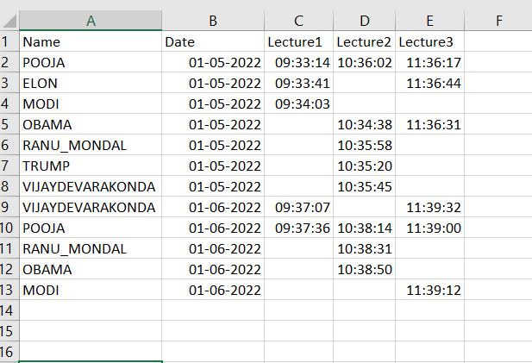

**Figure 5.51 : Attendance Marked**

**Analysis**

* In figure 5.51 we see that there are 5 columns
* The first column is used to store name or ID of a person
* Second column is used to store the date
* Third column is used to store the time when a person attends for first lecture, between 9-10 am
* Next column is used to store the time when a person attends for second lecture, between 10-11 am
* Last column is used to store the time when a person attends for last lecture, between 10-11 am
* We can also see in the figure that, if a person doesn’t attend previous lectures on the same day, the cell is left blank, indicating absent
* If a person comes for attendance in any other time , other than lecture time, he is recognised correctly, but attendance is not marked

**5.6 New registration**

Registration process

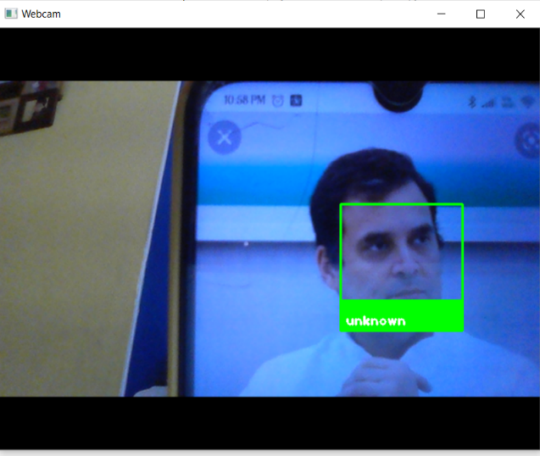

**Figure 5.61 : Input For New Registration**

[elon , modi , Obama , pooja, ranu_mondal , trump , VijayDevarakonda]

[0.77839176 0.7445644 0.80165922 0.86194385 0.8509388 0.88001054 0.66669 ]

WARNING: unknown face detected

Case 1: Correct Password entered

Password 1234

Enter name: Rahul

* If the correct Password is entered , then we are prompted to enter the name, upon which the unknown user is registered with their name as the identity in our database
* When correct password is entered then figure 5.61 is stored in the database with entered name as his ID

Case 2 : Wrong password entered

Password 0

unauthorised registration

* If the password is wrong, a warning for unauthorised registration is generated, and no further processing of the unknown user is done.
* When wrong password is entered, the captured image as shown in figure 5.61 is discarded.

**5.7 Speech output**

importpyttsx3  
engine = pyttsx3.init()

engine.say(name)  
engine.runAndWait()

* Whenever a face is recognised, the system spells out the name or ID of the person .
* This indicates to the student that his/her attendance has been marked successfully.

**5.8 Face Recognition In Different Scenarios**

**5.8.1 Makeover**

 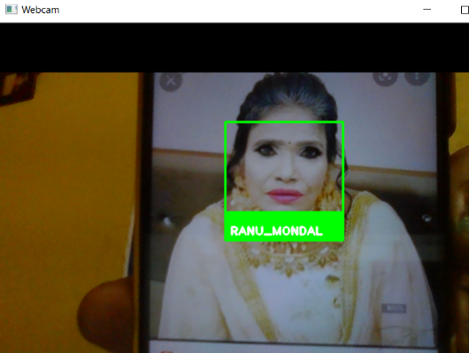

**Figure 5.81 : Natural Figure 5.82 : After Transformation**

( Here we see that even after a huge makeover as in fig 5.82, the face is rightly recognised for the fig 5.81, stored in the database)

**5.8.2 Beard**

 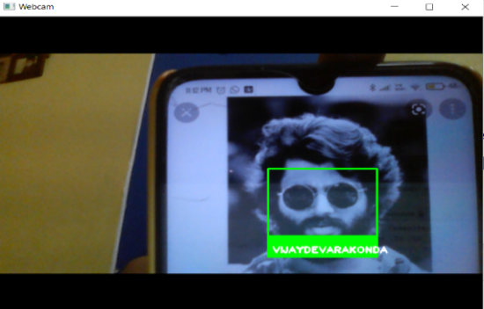  
 **Figure 5.83 : Without beard Figure 5.84 : With beard**

( We have the image shown in fig 5.83 in our database. Even with huge facial hair as shown in fig 5.84, the person is rightly recognised by our attendance system )

**5.8.3 Age**

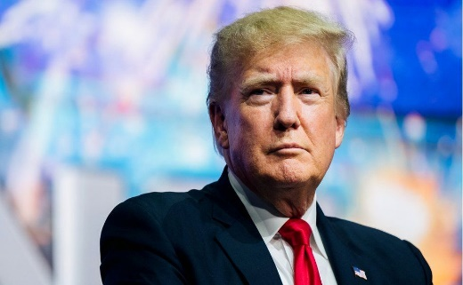 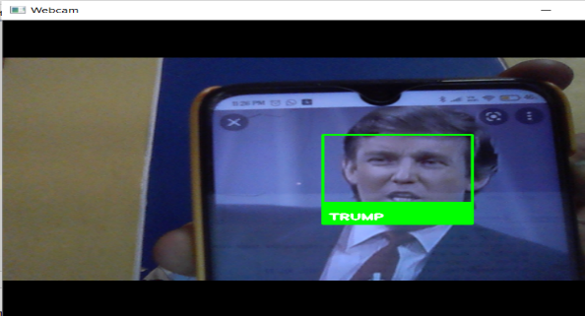  
 **Figure 5.85 : Old Age Figure 5.86 : Young age**

( We have Trump’s image in old age as in fig 5.85 stored in our database. Yet the young image of trump as shown in fig 5.86 is identified correctly )

**5.8.4 Combining two Different Faces**

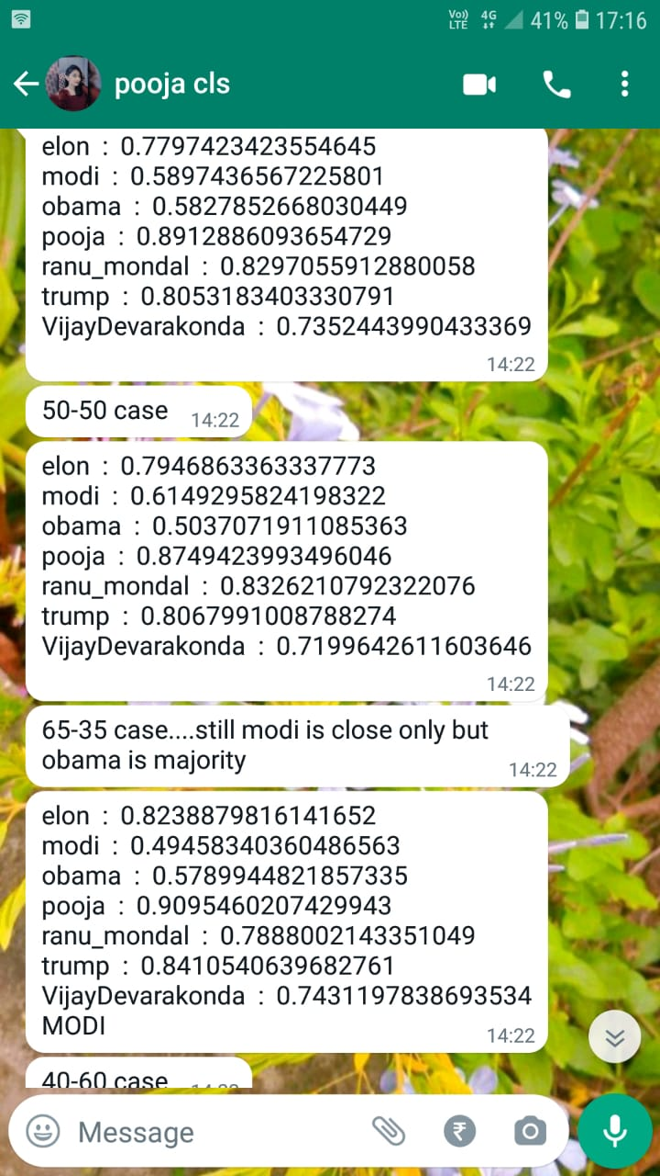Case 1 : Two faces merged with 50% each

* Here we see that, when two persons faces are morphed/merged together as in figure 5.87 , the result is ambiguous.
* The face distance has a smaller value for both Modi and Obama, whereas larger values for other faces
* The recognition is ambiguous because the face distance is almost equal for both the faces merged

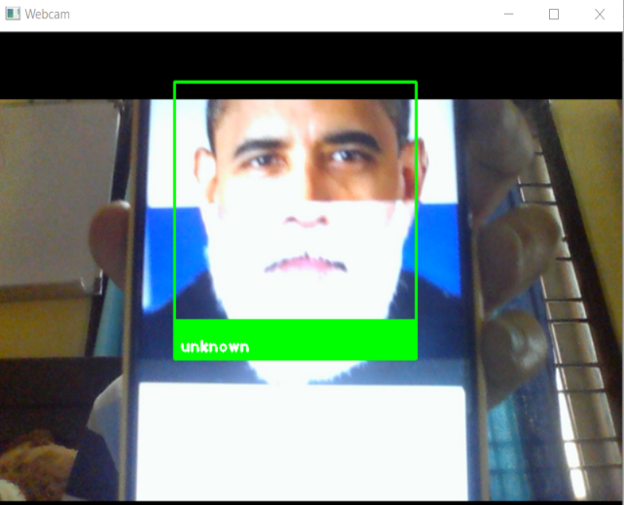

**Figure 5.87 : 50 percent of 2 different faces**

Case 2 : One face with 60% and other 40% occupancy



MODI

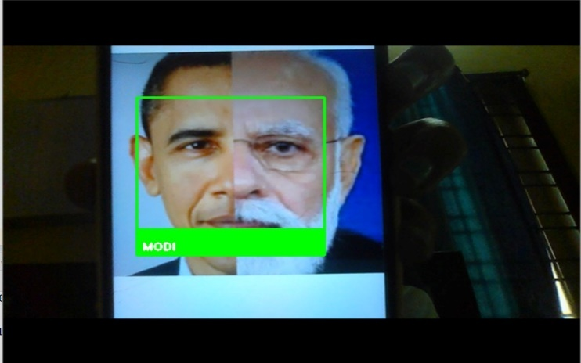

**Figure 5.88 : 60 percent Modi and 40 percent Obama**

* Here we see that, when two persons faces are morphed/merged together , Modi 60% and Obama 40% as in figure 5.88 , the result is Modi.
* The face distance has a smaller value for both Modi and Obama, whereas larger values for other faces
* The recognition is not ambiguous this time, because the face distance is small for both Obama and Modi , but it is smallest for Modi only.

Case 3 : One face with 35% and other 65% occupancy



OBAMA

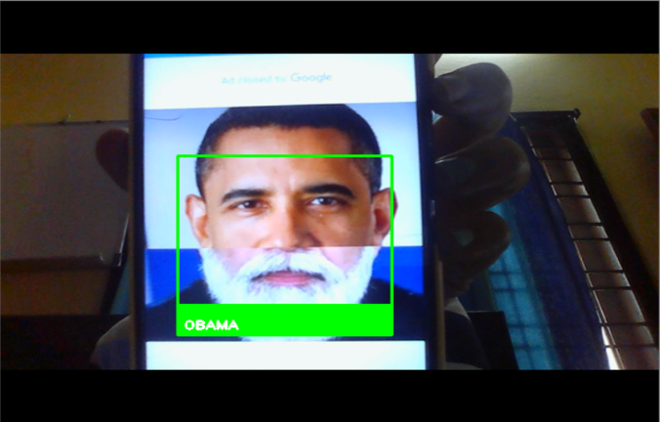

**Figure 5.89 : 65 percent Obama and 35 percent Modi is detected as Obama**

* Here we see that, when two persons faces are morphed/merged together , Modi 35% and Obama 65% as in figure 5.88 , the result is Obama.
* The recognition is not ambiguous this time, because the face distance is small for both Obama and Modi , but it is smallest for Obama only.

**5.9 Blurring The Image**

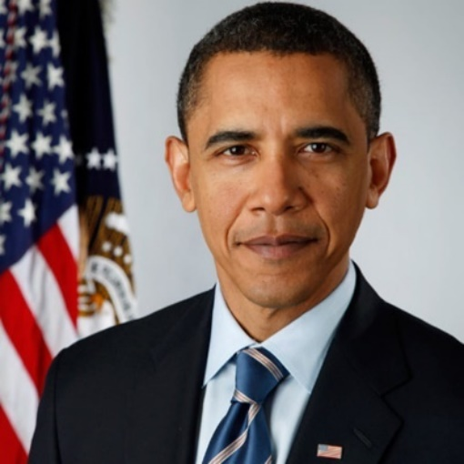 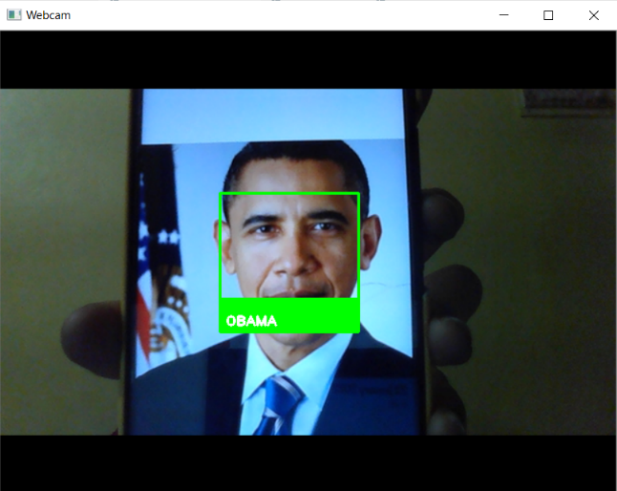

**Figure 5.91 : No Blur Figure 5.92 : Original image detected**

(When there is no blur effect as in fig 5.91 then image is recognised normally as in fig 5.92 )

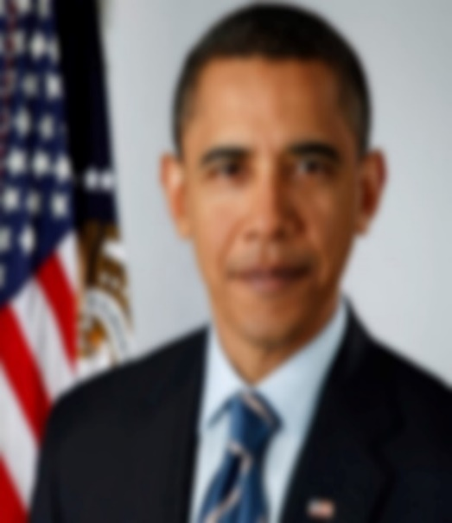 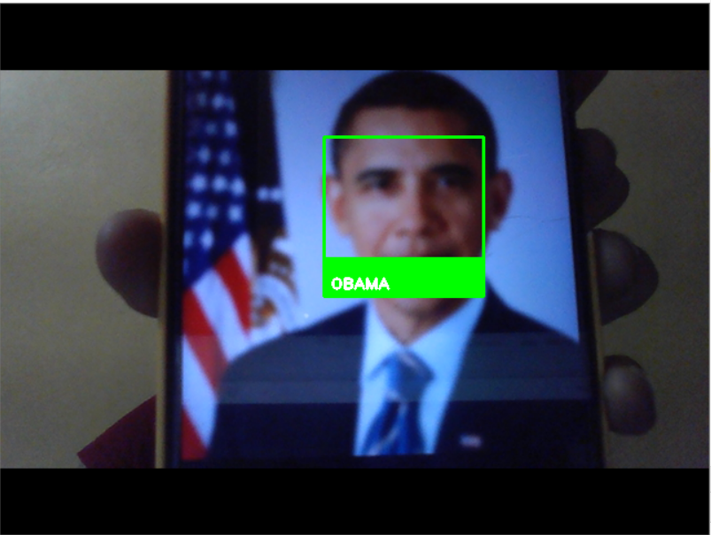

**Figure 5.93 : 30% blurring Figure 5.94 : 30 % blurred image Recognised**

(When a blur of 30% as in fig 5.93 is applied the face is still recognised as in figure 5.94. )

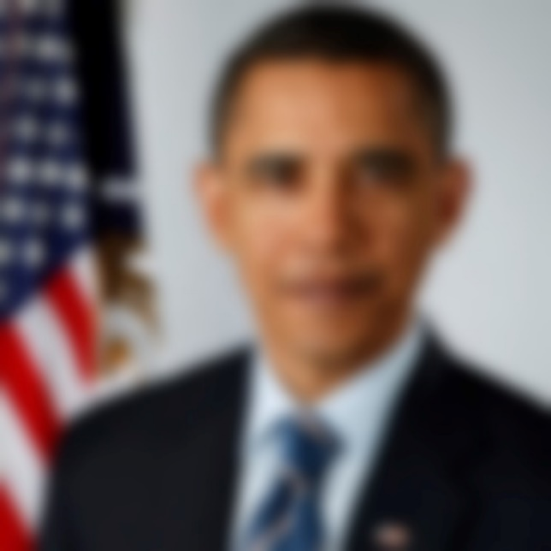 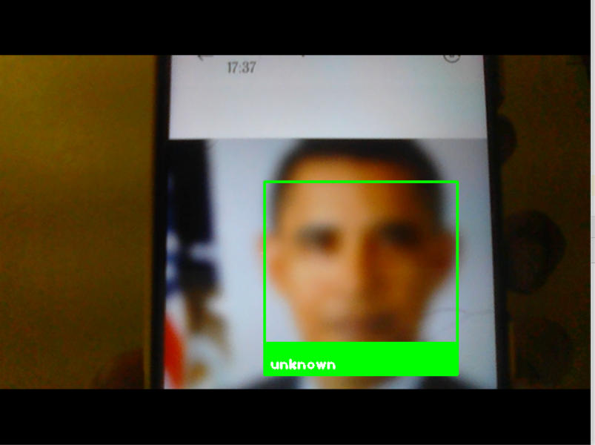

**Figure 5.95 : 60% Blurring Figure 5.96 : 60% blur detected as unknown**

(When a blur of 60% is applied as shown in fig 5.95, then the face is not recognised as in fig 5.96 )

* We see that even with the application of blur effect, face recognition is still possible
* But as the blurring effect increases, the rate of recognition decreases.

**CHAPTER 6**

**ADVANTAGES AND DISADVANTAGES**

### **ADVANTAGES OF FACE RECOGNITION**

### **1.Better security**

### Face detection augments surveillance tactics and forms the basis of the identification process of terrorists and criminals;

### 2.**Easy to integrate**

### Most face detection solutions are compatible with security software;

**3.Automated identification**

Face detection lets facial identification be automated, thus increasing efficiency alongside a heightened rate of accuracy

**4.Entry and Exit time automated record.**

Offices or workplaces or even just public places where the entry and exit times of employees or a person are strictly noted down will have a ready-made automated system to record the entry and exit time of each person for a given time.

**5. Cost-effective**

Since the whole process will be done by a computer, it means the total attendance registration and calculation will be automated and done by the system itself, therefore, saving us the money which would have been otherwise spent on the labour cost to do that.

**DISADVANTAGES OF FACE RECOGNITION**

1.**Huge storage requirements**

Machine learning technology requires powerful data storage

2.**Detection can be vulnerable**.

We’ve outlined the way in which facial detection can be thrown off

**3.Potential privacy issues.** There is disagreement on whether face detection is compatible with human privacy rights.

**CHAPTER 7**

**FUTURE SCOPE**

Almost all academic institutions require attendance record of students and maintaining attendance manually can be hectic as well as time consuming task.

Hence maintaining attendance automatically with the help of face recognition will be very helpful and less prone to errors as compared to manual processes. This will also reduce manipulation of attendance records done by students and it will save time as well. The future scope of the proposed work can be, capturing multiple detailed images of the students and using any cloud technology to store these images. The system can be configured and used in ATM machines to detect frauds. Also, the system can be used at the time of elections where the voter can be identified by recognizing the face.

**CHAPTER 8**

**CONCLUSION**

As a conclusion, this proposal successfully uses various image processing techniques for face recognition and updating attendance. It uses the Hog representation of images to detect faces in an image. It utilizes convolutional network (Resnet) face encoding approaches for feature extraction. The results of Feature extraction act as an accurate method of face recognition using Euclidean face distance. It proposes an image processing system that uses Python software for Automatic attendance update system.

This proposed system solves the potential problems of the classic attendance marking systems, which are inefficient and time consuming and pose a risk of proxies. The various image processing techniques used are the strength of this approach, which increase the efficiency.

**CHAPTER 9**

**REFERENCES**

* Omar Abdul, Rahman Salim, Rashidah Funke Olan-rewaju, Wasiu Adebayo Balogun. “ Class Attendance Management System Using Face Recognition." 2018 7th International Conference on Computer and IEEE paper
* Class Attendance Management System using Facial Recognition Clyde Gomes1,4,∗, Sagar Chanchal2,∗∗, Tanmay Desai3,∗∗, and DiptiJadhav4,∗∗∗
* <https://face-recognition.readthedocs.io/en/latest/readme.html>
* <https://medium.com/@ageitgey/machine-learning-is-fun-part-4-modern-face-recognition-with-deep-learning-c3cffc121d78>
* <https://towardsdatascience.com/an-overview-of-resnet-and-its-variants-5281e2f56035>
* <https://cv-tricks.com/keras/understand-implement-resnets/>
* <https://ww2.mathworks.cn/help/deeplearning/ref/resnet50.html;jsessionid=f91c0c258644e3085a318d042310>
* <https://neurohive.io/en/popular-networks/resnet/>
* <https://towardsdatascience.com/implementing-a-resnet-model-from-scratch-971be7193718>
* <https://github.com/fchollet/deep-learning-with-python-notebooks/blob/master/first_edition/5.4-visualizing-what-convnets-learn.ipynb>